
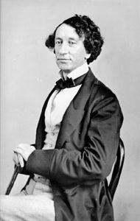
Sir John A (You’re OK)
#12
Mike Ford

from the album “Canada Needs You - vol. 1”

MapleMusicRecordings

Vocabulary

- architect
- annexationist
- appease
- B.N.A.
- beseeching
- bloodbath
- colonies
- Confederation
- corridors
- deadlock
- delegation
- emerged
- factions
- fatal
- intervened
- insatiable
- reciprocity
- residual powers
- scandal
- seize
- token
- tipple
- wherewithal

Do You Know It?

1. In what cities did the Fathers of Confederation meet to discuss Confederation?
2. What political term described uniting the British Colonies (Canada) from annexation or other threats?
3. What individual became a key leader of Confederation?
4. What date, (month and year) was Canada born or confederated?
5. Who was Canada’s first prime minister?



Did You Catch It?

- Who threatened to annex Canada in the mid 1800’s?
- What did some Canadians fear as a result of Confederation?
- For what type of government was John A. McDonald fighting?
- What happened to John A. when final preparations were in progress?
- What did John A. have to do to get Confederation passed?
- What were some of his goals to unify Canada?
- How many years did it take to construct the railroad?

55
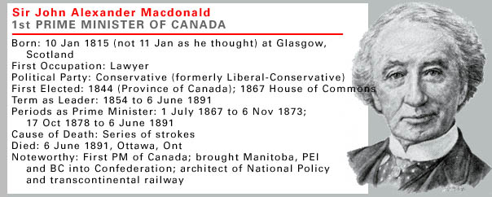
from : www.thecana

dianencyclopedia.com

Do You Get It?

1. What would John A. say today?

2.Is he “okay”? Why is John A. Macdonald sometimes viewed as a controversial figure in Canadian history?

3. What’s happening today (line 14)? Who are the “have” and “have-not” provinces?

4. Who would be considered the modern day Fathers of Confederation?

5. It was the railroad that once connected the country. How are Canadians “connected” today?

6. Why was the railroad so important to the creation of Canada as a nation?

7. What provinces joined Confederation in 1867?

Activities and Extensions!

1. Do a timeline showing the building of the railroad.
2. Research information about Sir John A. McDonald and develop a biography about him. This could be done in the form of a one-act play where Sir John A. McDonald talks about his life.
3. Write a diary as if you were one of the first people to cross Canada on the new railroad. Describe at least five places that you journeyed past.



Teacher’s Guide

BACKGROUND INFORMATION

In the 1860’s the British colonies in Canada faced many problems.
The problems faced were developing a strong economy, fending off annexation by the United States, and solving the political problems between the English-speaking and French-speaking halves of Upper and Lower Canada. Confederation became the solution. On July 1, 1867, Ontario, Quebec, Nova Scotia and New Brunswick joined together to become Canada. The other six provinces and territories took more than a century to join Confederation.

ANSWER KEY
Do You Know It? Answers:
- The Father’s of Confederation met in Charlottetown and Quebec City.
- The term is Confederation.
- John A. McDonald became a key leader of Confederation.
- Canada was born on July 1, 1867.
- Sir John A. McDonald was Canada’s first prime minister.

Did You Catch It? Answers:
- The United States threatened to annex Canada.
- Some Canadians feared a loss of influence, local power, culture, and ties to England.
- He wanted a strong central government.
- When final preparations were in progress, a candle caught the bed on fire.
- He had to wheel, deal, beseech and preach to get Confederation passed.
- Some of the goals were to unify Canada to develop a transcontinental railway and to settle the west.
- It took fifteen years to construct the railway.

Did You Get It? Answers:
- A variety of answers could be accepted.
- The term the have and have-not provinces is based on the economy of the various provinces. The richer provinces are the have provinces.
- Answers will vary.
- Possible answers could include thing like the CBC, hockey, pride of nation etc.
- The railway made it possible to settle the western provinces.
- New Brunswick, Nova Scotia, Ontario and Quebec joined at Confederation.

ADDITIONAL RESOURCES

www.collectionscanada.ca/educaton/kids
www.cbc.ed/history/
www.thecanadianencclopedia.com

Suggested Reading
Stewart K. Dicks, A Nation Launched: Macdonald's Dominion 1867-1896 (1978); Elma Schemenauer, John A. Macdonald (1987); Donald Swainson, Sir John A. Macdonald: The Man and the Politician (1990).

